**Chapter 7**

**SNAPSHOTS**

**7.1 Initial View:**

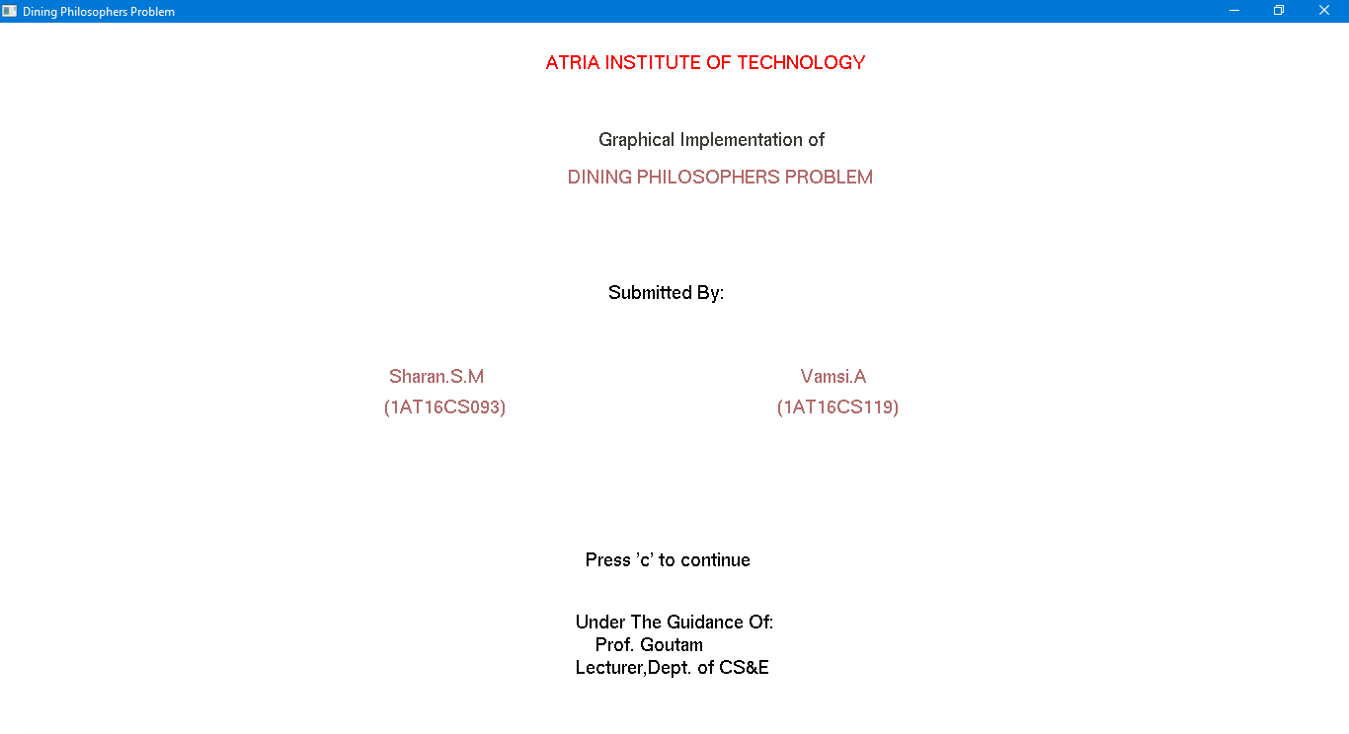

The snapshot above shows the first screen.

**7.2 Menu with options:**

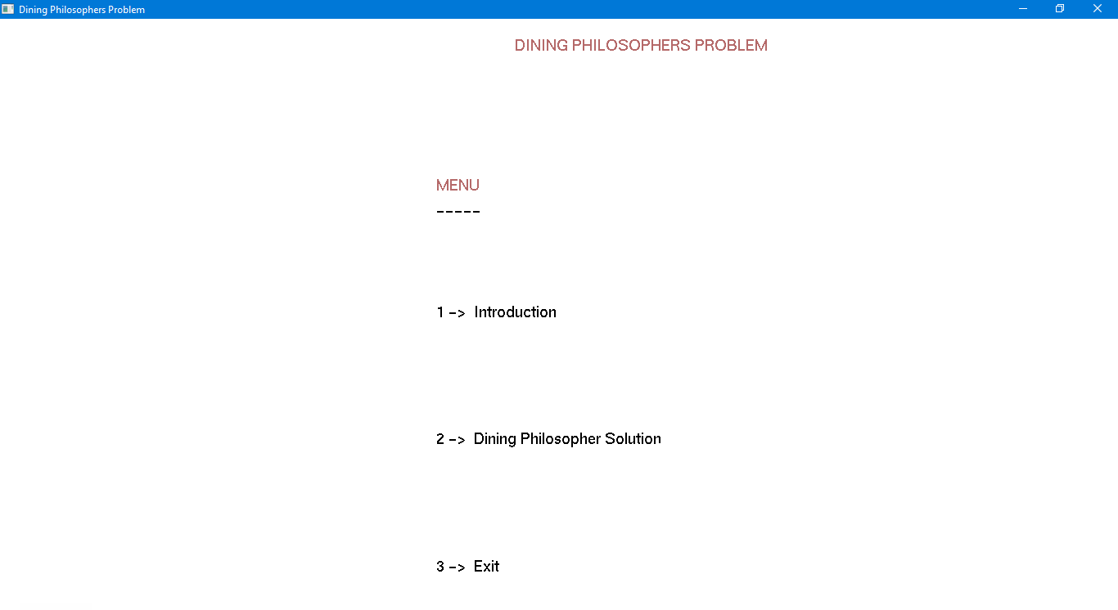

The snapshot above shows the menu containing different options.

**7.3 Introduction:**

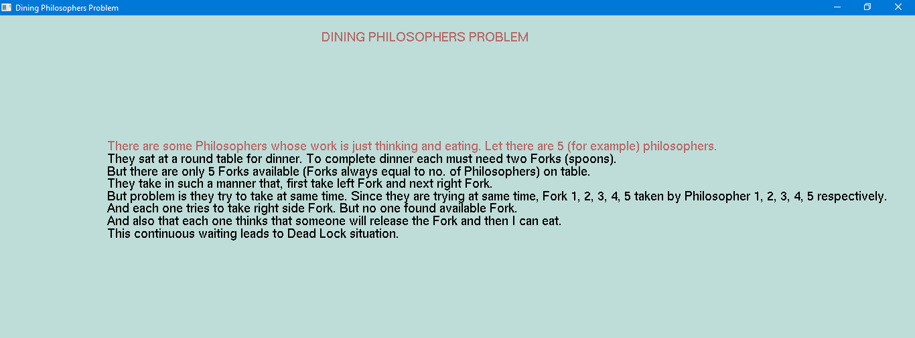

The snapshot above shows the description of the problem statement.

**7.4 Deadlock situation:**

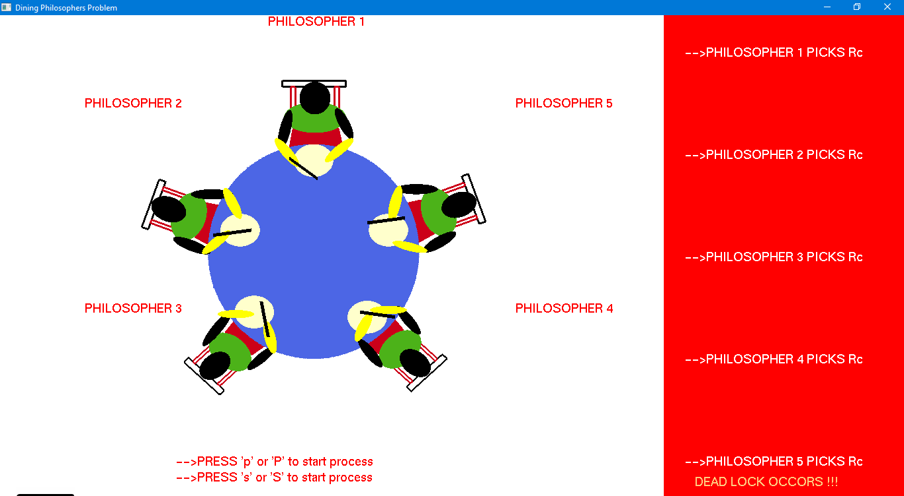

The snapshot above shows the deadlock situation.

**7.5 Solution for problem statement:**

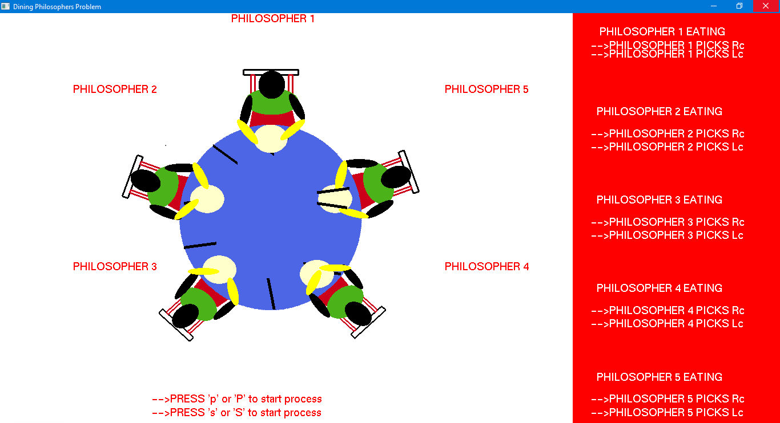

The snapshot above shows the solution of dining philosopher problem.